|  |  |
| --- | --- |
|  |  |

**eProject Document**

Cell-On Services

|  |  |
| --- | --- |
| **Group 4** | |
| **Members** | Dang Tuan Dat - Student1233994  Le Duc Viet – Student1262324 |
| **Instructor** | Hoang Van Chung |
| **Batch** | C1905M |
| **Semester** | III |

**🙠 Date of issue 29-08-2021 🙢**

**Table of Content**

1. **Problem definition**
   1. ***Introduction***
   2. ***Existing Scenario***
   3. ***Proposed scenario***
2. **Customer Requirement Specification**
   1. ***Customer Requirement***
   2. ***Hardware – Software Requirements***
3. **Architecture and Design of the System**
4. **Flow Chart**
5. **Data Flow Diagram**
6. **Entity Relationship Diagram**
   1. ***Entity relationship diagram***
   2. ***Entity - Attributes***
7. **Database Design/Structure**
   1. ***Database relationship diagram***
   2. ***Table design***
8. **Some typical interface**
9. **Task Sheet**
10. **Check List of Validation**
11. **Submission Checklist**
12. **Problem Definition**
    1. **Introduction**

Symphony Ltd. is private institute, which generally conducts the classes and training materials for the various certifications that are related to IT and Software industries like networking related, Java related, database related like for SQL Servers, oracle, etc. They are one of the famous institutions which have spread in to various branches situated at different location in the state.

They provide various resources like the preparation materials, lab facilities based on the subject, extra lab hours or sessions (offered after the course duration), 24 hours faculty guidance is provided for the lab sessions, assignments, Library facilities, etc.

* 1. **Existing Scenario**

Currently they advertise about the services that they provide through the pamphlets (available at the centers), advertisements in news papers, and through other media like through television advertisements, etc. in order to attract the people.

Usually they conduct the trainings on half yearly basis every year. They generally conduct an entrance exam through which they can know the knowledge level of the participant and thus depending on the exam marks they segregate the participants or the students into the appropriate class rooms like for the participant not having the minimum knowledge will be given training right from the basics till the certification level and for the participants having the minimum knowledge about the basics will be segregated in to the class where they direct start with the basic certification topics with out touching the basic concepts of the subject.

Once the examination results are out, they inform the participants with the results, and ask them to visit the institution on a particular date for counseling purpose, where they inform the students with which class they will be segregated and regarding the course fees based on the class segregated. If the student is interested in taking the class, then he will be provided with the class form in which he/she is segregated and then they are directed to the accounts department where the student needs to make the payment in order to join the class. The student can make the payment for the class, at least 1 day before the commencement of the class.

For the training with the basics they usually charge around 6000$, and the duration for the training will be for 6 months. And for the training with out the basics they charge around 4275$, and the duration will be for 4 months.

They also provide the practice sessions (extra lab sessions) separate from the course duration, i.e., after the successful completion of the course if the student wishes to practice the lab sessions at the lab in the institution, he (student) can prefer at the time of registering for the course. And for this they charge around 1000$ separately from the course fees. But the student has to opt it at the time of getting registered for the course itself. Else if student wants to opt for it at the end of the course based on his requirement, then they will charge 1500$.

Note: The extra lab sessions are only available for the students who have registered for the course offered by the institution. And for this they provide guidance too by one of the faculty members.

After the completion of the certification course, they conduct the final examination and based on the marks secured the respective faculty members provides the suggestions and feedback like what are areas of improvement, where extra practice is to be delivered, which other materials apart from the course materials can be preferred, etc. Thus, ensuring that they pay maximum attention to the students and making the student benefited for joining this institution.

For going into the library that the institution provides, the student must display his identity card. And they do not allow the student to carry out the library books to his / her house .

* 1. **Proposed Scenario**

Right now they want to incorporate online systems through which they can advertise about the services that they provide and thus ensuring that they gain the attention of the certification aspirants up to a maximum extent. So they have approached us so that we can provide an online portal where the different functions of the institution are displayed .

**► Non-Financial :**

They want the following functionalities to be incorporated on the portal.

1. There should be an admin login provided apart from the normal site function,

where the admin can enter the following information:

• List of the courses offered and the topics that are covered.

• New courses if any

• The Entrance Examination Information

• Displaying the results. On this page the admin should be able to enter the

student’s details like the roll number, name and the marks secured by

him/her and the class into which he/she is segregated, and the fees details

with respect to the class that the student is segregated into.

• About us (on this page the admin can enter or update the information about the institution)

• FAQ’s Page (On this page the admin should be able to enter, update or

delete the FAQ’s)

1) How to join the course? (On this the admin should be able to

enter or update the procedures for joining the course that the

institute offers)

2) Why to join the institute? (The various benefits that the student

can gain by joining the institution is to be provided)

3) When will be Entrance Examinations Conducted? (Once in 6

months, and one need to check the website for knowing when is

the entrance exam entitled, the fees for the entrance exam (admin

will decide and displayed on the application form), etc. are to be

listed

4) Can I use the Lab facilities after my class hours? Will there be

any extra hidden charges? (Ans: Yes, you can use the lab

sessions even after your class hours. There will be no charges

during the course days (i.e., during the course period if you want

to use the lab sessions after the class hours we do provide the lab

session and the labs will be kept opened till 9 PM in the evening.

But yes if you want to use the lab session after your course

completion, then it will be charged based on the scenario (like

1000$ if opted at the time of registering and 1500$ if opted after

the completion of the course)

5) How can I apply for the entrance exam? (Ans: once the entrance

exams are entitled, one need to visit the center for applying it

through paper and fill all the necessary details through online. On

the application form one should chose which course he/she

wanted to pursue.)

6) Will there be any fees for the entrance exam? (Ans: Yes there

will be and it will be available on the application form)

7) How to make the payment? (Ans: payment can be done through

draft, or through cheque or through cash. For making the

payment through cash, one needs to come to one of the center of

the institute, and make the payment there itself. Once the

payment is done (through cash or through DD), the student will

be provided with the receipt with a receipt number. This receipt

number is to be inputted in the application form. For the

payments done through cheque and DD, one need to enter the

DD number and the cheque number, bank details, etc. are to be

entered on the application form and the cheque is to be pinned to

the application form. Only once the payment is received the

student’s application will be accepted. Once the application is

accepted, the student is mailed with the acknowledgement form

along with the details of the examination, subject chosen, date

and time of exam, and the roll number).

• Contact Us Page (on this page, the admin should be able to enter or update or delete the list of the center of different branches that are available and their addresses along with the telephone numbers)

2. The normal site function should have the following

• Home page (On this page the brief description of the institute and that of

the courses offered, new course details, etc. are to be displayed.

• About Us

• Course details (on this page the list of the various courses offered are to be displayed along with the topics that each course covers) Entrance Examination (on this page one should be able to view the details

of the upcoming entrance examinations, and the results of the last exam

that is conducted. For viewing the results one must click the link which

will direct to the page that asks for the roll number, now the student must

enter the roll number which is provided on the acknowledgement card after

the acceptance of his/her application. If the student’s roll number is

existing then the result secured by the student will be displayed, else a

message stating that there is no such roll number in the database is to be

displayed. Along with the result of the student, the class he/she has been

segregated to and the course fees based on the class segregated are to be

displayed and the last date for making the payment is to be displayed)

• FAQ’s

• Contact Us (the list of the various centers located at different places will be displayed)

**► Financial :**

The course fees, entrance exam fees will be decided by the admin alone. They can be varied from time to time.

1. **Customer Requirement Specification**
   1. **Customer Requirement**
      1. **Users of the system**

* Admin
* Customer
  + 1. **System functions**

|  |  |
| --- | --- |
| **User** | **Functions** |
| **All Users** | * Login * Change Profile |
| **Admin** | * View List Courses * Enter, Create, Delete, Update Courses * View Upcoming Courses * View Student Results * Enter, Create, Delete, Update Students * Enter, Create, Delete, Update Information about Institute * Enter, Create, Delete, Update Contacts * Enter, Create, Delete, Update FAQ’s |
| **Customer** | * View Courses , Admissions , Category * Register Information * View Teachers , Branchs , FAQs |

* 1. **Common functions**

|  |  |
| --- | --- |
| **Login** | |
| Input | Login to system, admin must be enter username and password |
| Process | Access information in database |
| Output | Result of login |
| **Change Profile** | |
| Input | Information details of admin such as Name, Address, Phone, Email … |
| Process | Maintain user’s information details |
| Output | Result of Change profile |

* 1. **Admin functions**

|  |  |
| --- | --- |
| **Courses management** | |
| Input | Information details of courses such as Name, Time, Image, … |
| Process | Access information in database to modify, add to database, delete from database. |
| Output | Display or maintain Information detail of Courses. |
| **Students management** | |
| Input | Information details of Students such as Name, Address, Phone, Email,… |
| Process | Access information in database to modify, add new students to database, delete from database. |
| Output | Display or maintain Information detail of Students. |
| **Entrance Examintaion management** | |
| Input | Information details of Examination such as Name, Time,… |
| Process | Add new Entrance Examination to database |
| Output | Display Examination |
| **About Us management** | |
| Input | Information details about Institude |
| Process | Access information in database to modify, add new information to database, delete from database. |
| Output | Display information |
| **Contact Us management** | |
| Input | Information details about the list of the centres of different branches that are available and their addresses along with the telephone numbers. |
| Process | Access information in database to modify, add new information to database, delete from database. |
| Output | Display information |
| **FAQ management** | |
| Input | Information details about Frequently Asked Questions |
| Process | Access Questions and Answers in database to modify, add new Questions and Answers to database, delete from database. |
| Output | Display FAQ |

* 1. **Hardware – Software requirement**

### Minimum Hardware Requirements

* CPU: Pentium IV 2.00 GHz.
* RAM: 512 MB.
* Hard Disk: 5 GB.
* OS: Window 2000/XP/Server 2003.

### Recommended Hardware Requirements

* CPU: Dou Core 2.00 GHz or higher.
* RAM: 2 Gb or higher.
* Hard Disk: 80 GB or higher.
* OS: Window XP SP3 / Window 7

### Software Requirements

* Environment: Microsoft .NET Framework 2.0 or later
* Database Management System: Microsoft SQL Server 2005 or later
* IDE: Microsoft Visual Studio 2008 or later
* Web Server: Internet Information Services (IIS 7.0) or later

1. **Architecture and design of the system**

The Application will be made of a Web-based distributed three-tier architecture.

Web - Tier

User Interface with HTML

And ASPX pages

C# (Code - behind) file containing

Middle Tier

business logic

SQL Server 2014

Database - Tier

**Web – based distributed 3 - Tier Architecture of the Project**

1. **Flow chart**
   1. **Login**

Start

Start

Display confirm exit

Input data

Check Data

Display Error

**false**

Logout

**true**

Stop

Successful login

b. System Logout

Stop

1. System Login
   1. **Add / Update Data**

Start

Start

Load data

Input Data

**false**

Display error

Input Data

Display error

Check Data

**true**

Check Data

Save database

**false**

**true**

Save database

Display messenger

Display messenger

Stop

1. Add data

Stop

b. Update data

* 1. **Search data**

Start

Input keyword

Display error

Check data

**false**

**true**

Display result

Stop

* 1. **Delete Data**

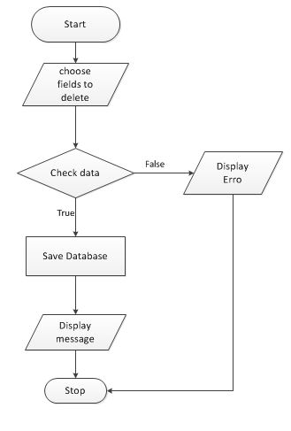

1. **Data flow diagram**
   1. **General Diagram**

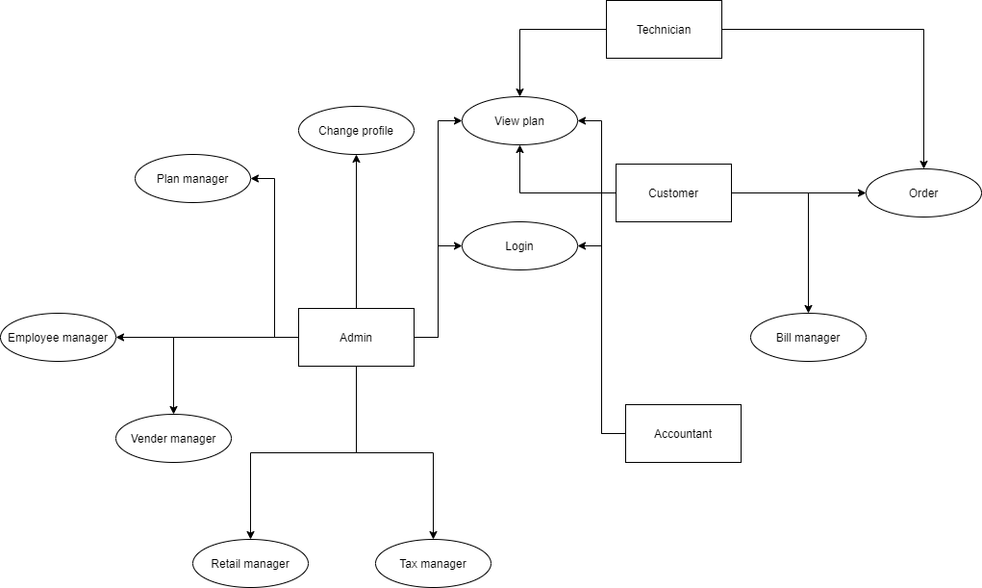

* 1. **Use case**

1. Login

Admin

Users

1. Change Profile

Admin

Users

1. Search

Users

1. Plan Management

Plan Manager

Admin

1. Bill Management

Bill Manager

Accountant

1. Retail Shop Management

Retails Management

Admin

1. View Orders

Customers

Users

1. **Entity relationship diagram**
   1. **Entity relationship diagram**

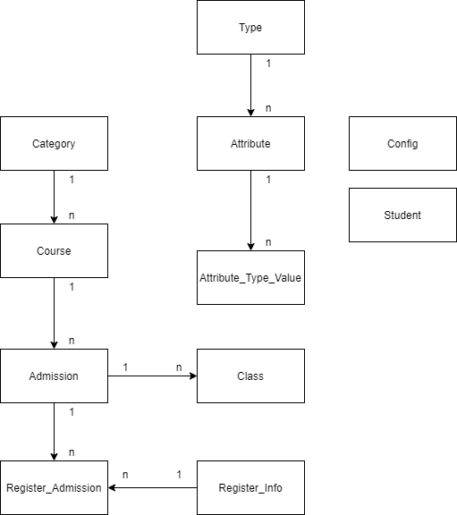

* 1. **Entity - Attributes**

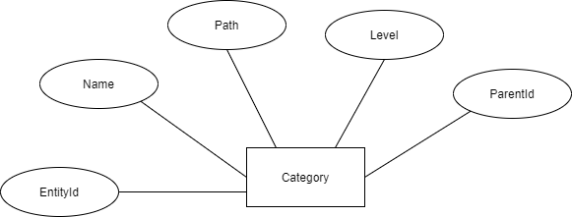

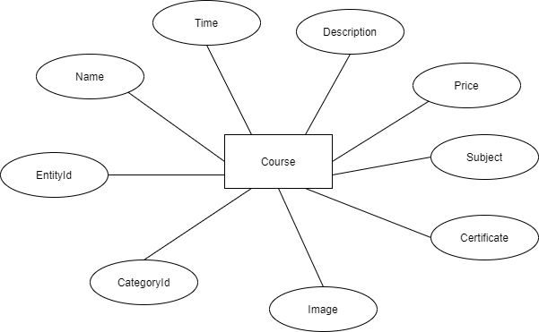

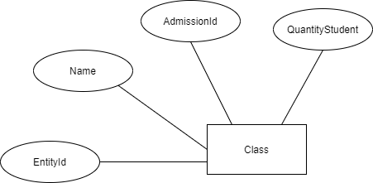

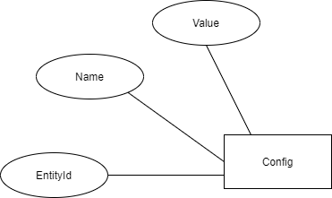

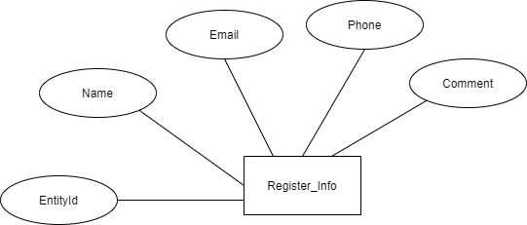

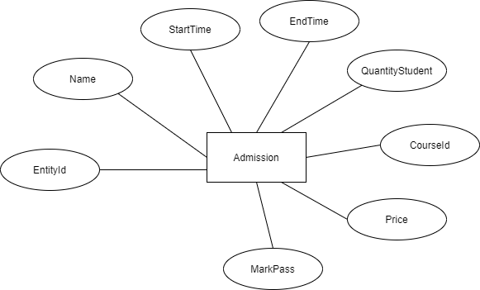

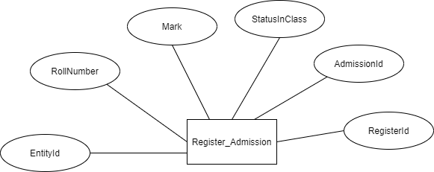

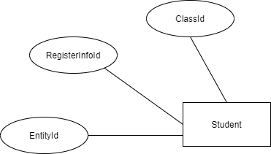

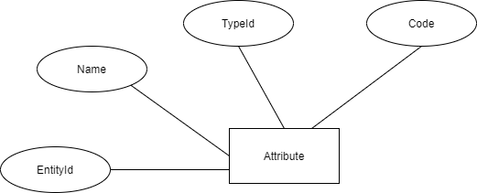

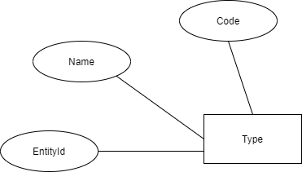

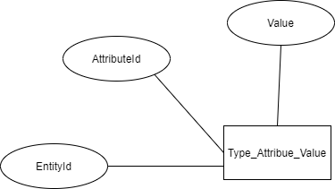

1. **Database Design/Structure**
   1. **Database relationship diagram**

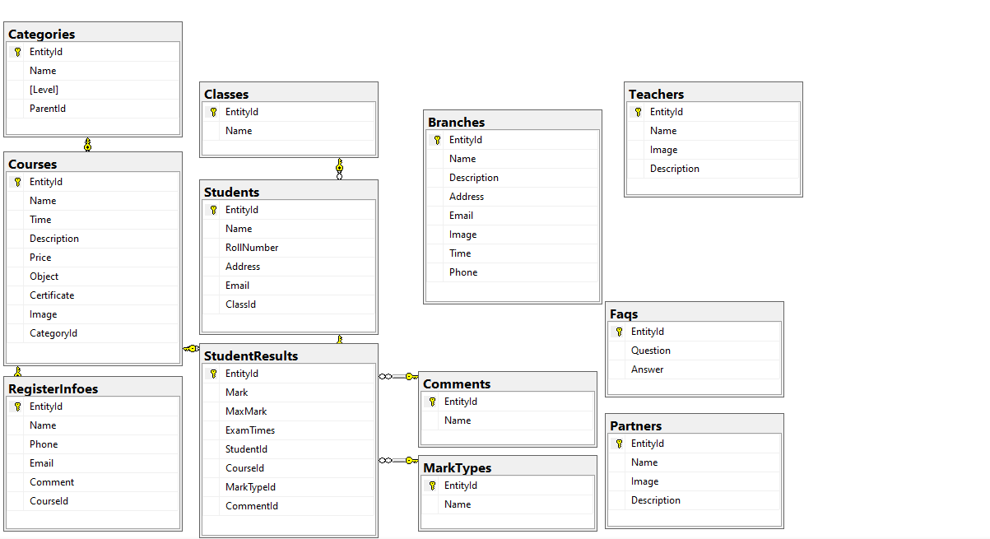

* 1. **Table Design**

|  |  |  |  |  |
| --- | --- | --- | --- | --- |
| **Table:** **Customers** | | | | |
| **Column** | **Data type** | **Allow Nulls** | **Key** | **Description** |
| CustomerId | Int | 🞎 | PK | CustomerId |
| CustomerName | String | 🞎 |  | CustomerName |
| FistName | String | 🞎 |  | FistName |
| LastName | String | 🞎 |  | LastName |
| Email | String | 🞎 |  | Email |
| Phone | String | 🞎 |  | Phone |
| Password | String | 🞎 |  | Password |

|  |  |  |  |  |
| --- | --- | --- | --- | --- |
| **Table:Users** | | | | |
| **Column** | **Data type** | **Allow Nulls** | **Key** | **Description** |
| UserId | Int | 🞎 | PK, Auto | UserId |
| UserName | String | 🞎 |  | UserName |
| Password | Int | 🞎 |  | Password |
| Email | String | 🞎 |  | Email |
| Phone | Int | 🞎 |  | Phone |

|  |  |  |  |  |
| --- | --- | --- | --- | --- |
| **Table:** **Slider** | | | | |
| **Column** | **Data type** | **Allow Nulls** | **Key** | **Description** |
| SliderId | Int | 🞎 | Primary Key | SliderId |
| SliderName | String | 🞎 |  | SliderName |
| Images | String | 🞎 |  | Images |
| DisplayNo | String | 🞎 |  | DisplayNo |
| Status | Bit | 🞎 |  | Status |

|  |  |  |  |  |
| --- | --- | --- | --- | --- |
| **Table:Orders** | | | | |
| **Column** | **Data type** | **Allow Nulls** | **Key** | **Description** |
| OrderId | Int | 🞎 | PK, Auto | OrderId |
| CustomerId | String | 🞎 |  | CustomerId |
| FullName | String | 🞎 |  | FullName |
| Email | String | 🞎 |  | Email |
| Phone | String | 🞎 |  | Phone |
| Address | String | 🞎 |  | Address |
| Total | String | 🞎 |  | Total |
| Created | DateTime | 🞎 |  | Created |
| Status | Bit | 🞎 |  | Status |

|  |  |  |  |  |
| --- | --- | --- | --- | --- |
| **Table: OrderDetail** | | | | |
| **Column** | **Data type** | **Allow Nulls** | **Key** | **Description** |
| OrderId | Int | 🞎 | ForeignKey | OrderId |
| ProductId | Int | 🞎 | ForeignKey | ProductId |
| Quantity | Varchar(100) | 🞎 |  | Quantity |
| Price | Varchar(20) | 🞎 |  | Price |

|  |  |  |  |  |
| --- | --- | --- | --- | --- |
| **Table:Ingredient** | | | | |
| **Column** | **Data type** | **Allow Nulls** | **Key** | **Description** |
| IngredientID | Int | 🞎 | Primary Key | IngredientID |
| RecipeID | String | 🞎 | ForeignKey | RecipeID |
| Content | String | 🞎 |  | Content |

|  |  |  |  |  |
| --- | --- | --- | --- | --- |
| **Table:Directions** | | | | |
| **Column** | **Data type** | **Allow Nulls** | **Key** | **Description** |
| DirectionsID | Int | 🞎 | PK | DirectionsID |
| RecipeID | String | 🞎 | FK | RecipeID |
| Content | String | 🞎 |  | Content |

|  |  |  |  |  |
| --- | --- | --- | --- | --- |
| **Table: Blogs** | | | | |
| **Column** | **Data type** | **Allow Nulls** | **Key** | **Description** |
| BlogID | varchar(20) | 🞎 | PK | ID of Blog |
| BlogName | varchar(50) | 🞎 |  | Name of Blog |
| BlogContent | text | 🞎 |  | Address of Blog |
| BlogAuthor | varchar(50) | 🞎 |  | Author of Blog |
| BlogFeatureImg | varchar(20) | 🞎 |  | FeatureImg of Blog |
| CreateBlog | varchar(20) | 🞎 |  | Create of Blog |

|  |  |  |  |  |
| --- | --- | --- | --- | --- |
| **Table: Favourites** | | | | |
| **Column** | **Data type** | **Allow Nulls** | **Key** | **Description** |
| FavoriteID | varchar(20) | 🞎 | PK | ID of Vendor |
| RecipeId | varchar(50) | 🞎 | FK | Name of Vendor |
| CustomerID | Int() | 🞎 | FK | Address of Vendor |

|  |  |  |  |  |
| --- | --- | --- | --- | --- |
| **Table: FAQs** | | | | |
| **Column** | **Data type** | **Allow Nulls** | **Key** | **Description** |
| FaqsID | Int() | 🞎 | PK | FaqsID |
| Question | varchar(50) | 🞎 | FK | Question |
| Answer | varchar(50) | 🞎 | FK | Answer |

|  |  |  |  |  |
| --- | --- | --- | --- | --- |
| **Table: Recipes** | | | | |
| **Column** | **Data type** | **Allow Nulls** | **Key** | **Description** |
| RecipeId | Int | 🞎 | PK | OrderId |
| Name | Int | 🞎 |  | ProductId |
| Description | Varchar(100) | 🞎 |  | Quantity |
| Image | Varchar(100) | 🞎 |  | Image |
| Price | Float | 🞎 |  | Price |

|  |  |  |  |  |
| --- | --- | --- | --- | --- |
| **Table:Comments** | | | | |
| **Column** | **Data type** | **Allow Nulls** | **Key** | **Description** |
| CommentID | Int | 🞎 | PK | CommentID |
| CustomerID | Varchar(50) | 🞎 | FK | CustomerID |
| RecipeID | Varchar(100) | 🞎 | FK | RecipeID |
| Content | Varchar(50) | 🞎 |  | Content |

1. **Some typical interface**

**8.1) Login Admin**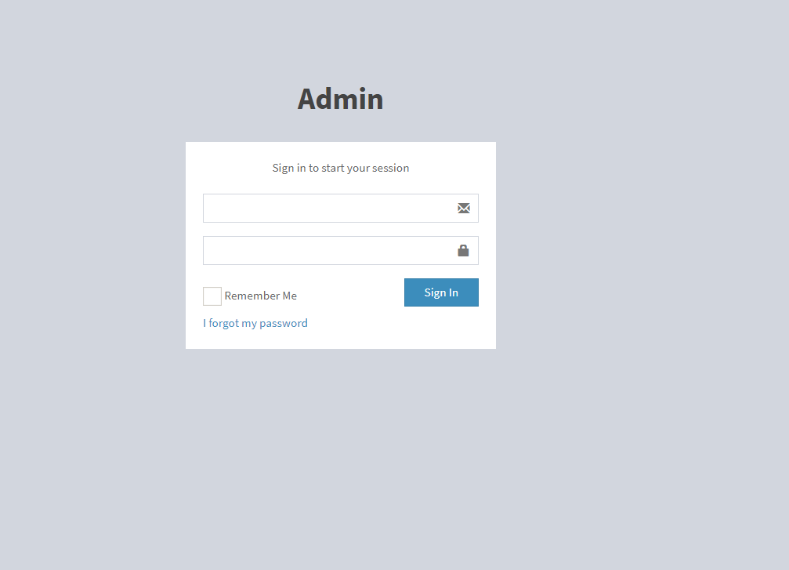

**8.2) Recipe**

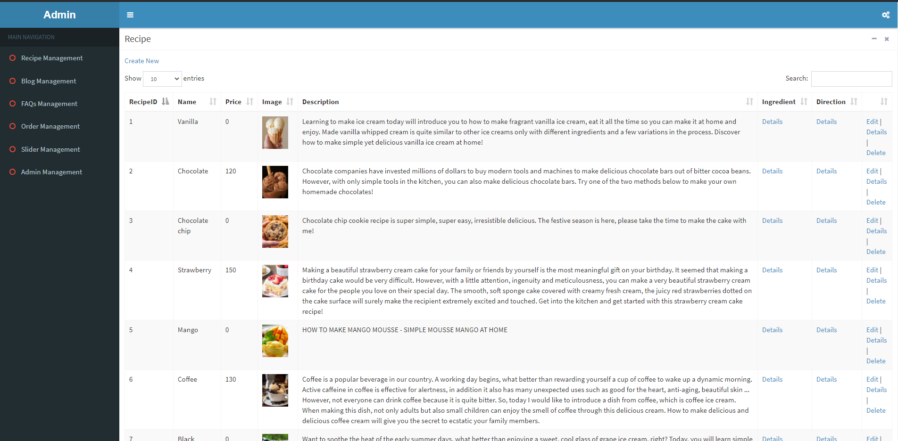

**8.3) User**

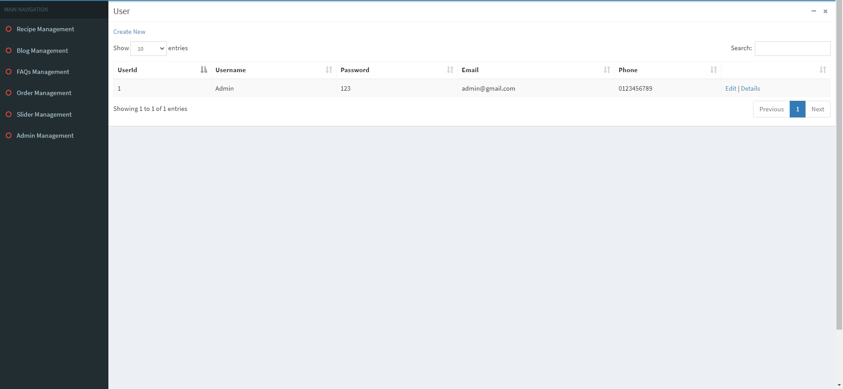

**8.4) Blog**

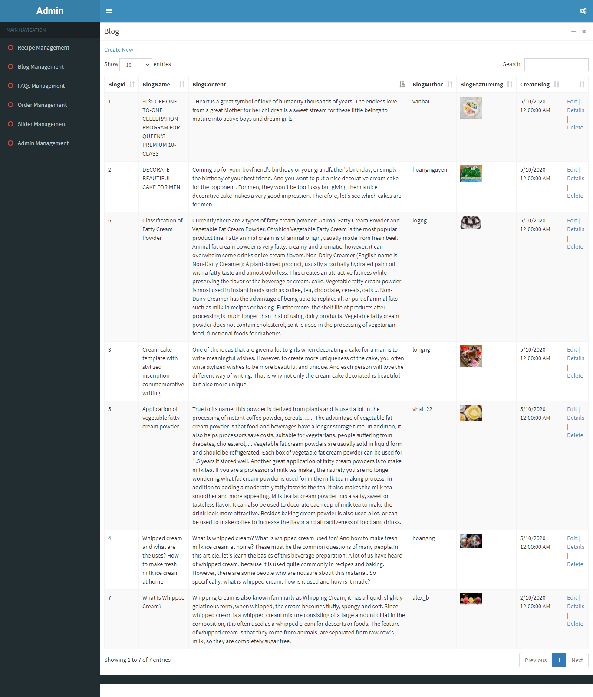

**8.5) Order**

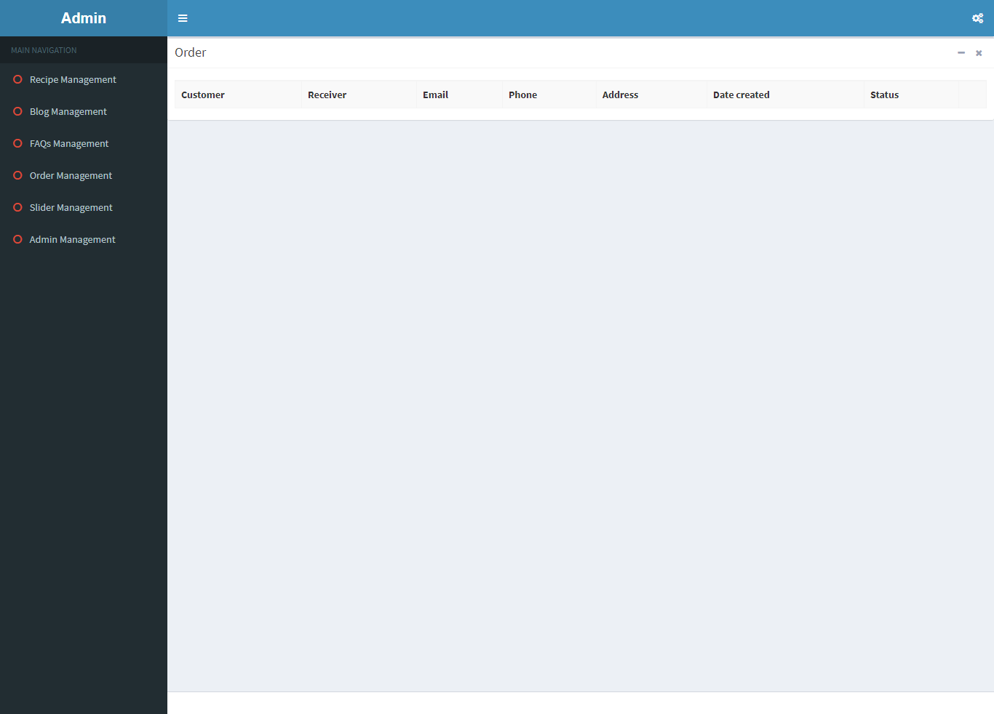

**8.6) Slider**

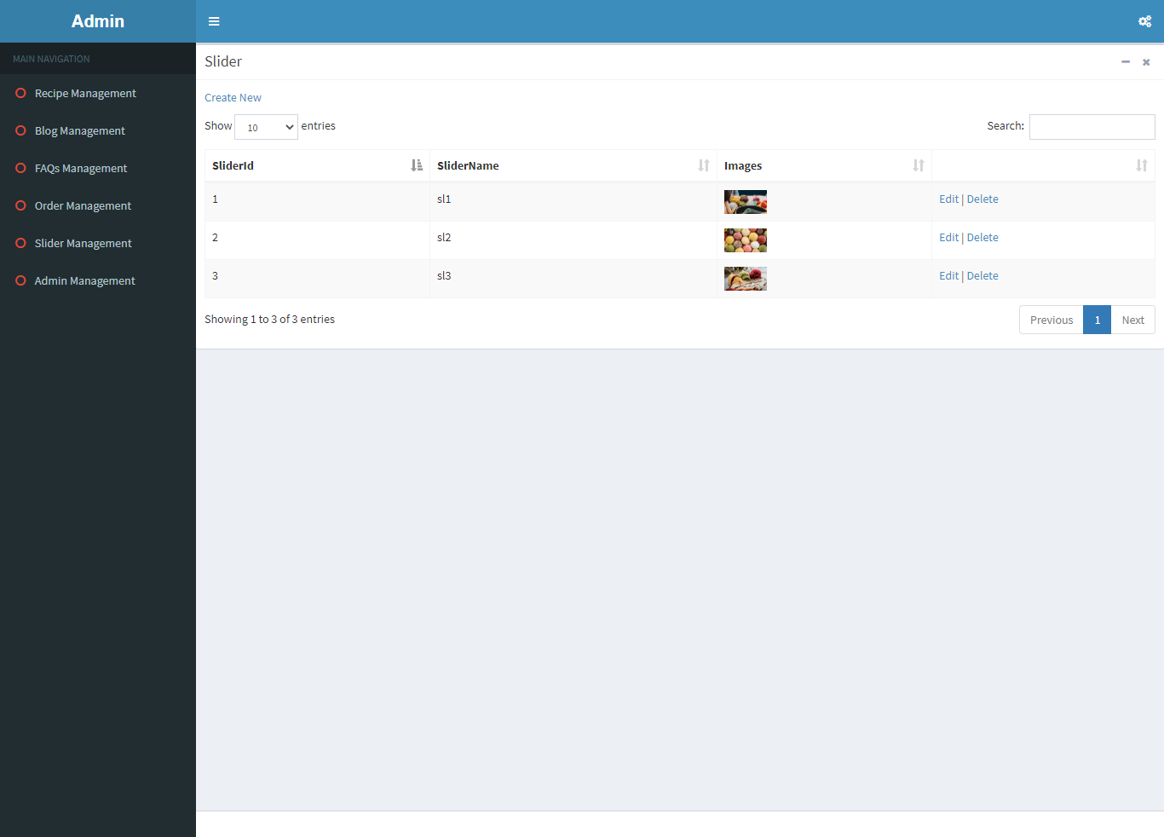

**8.7) FAQs**

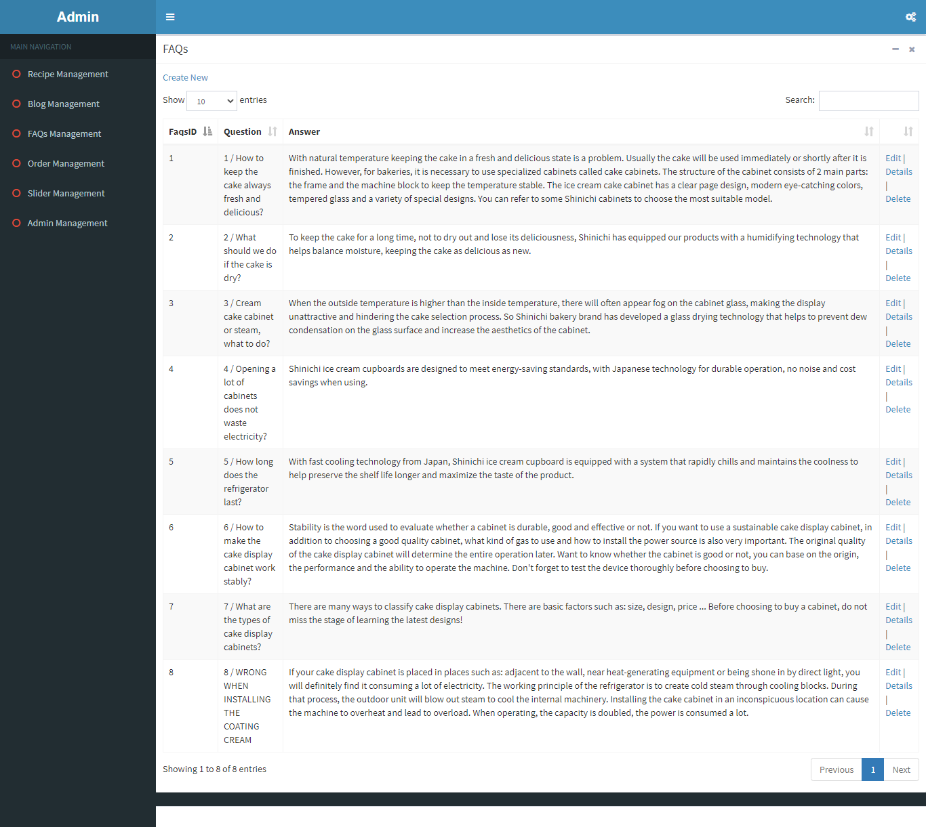

**9) Some typical interface**

**9.1) Trang chủ**

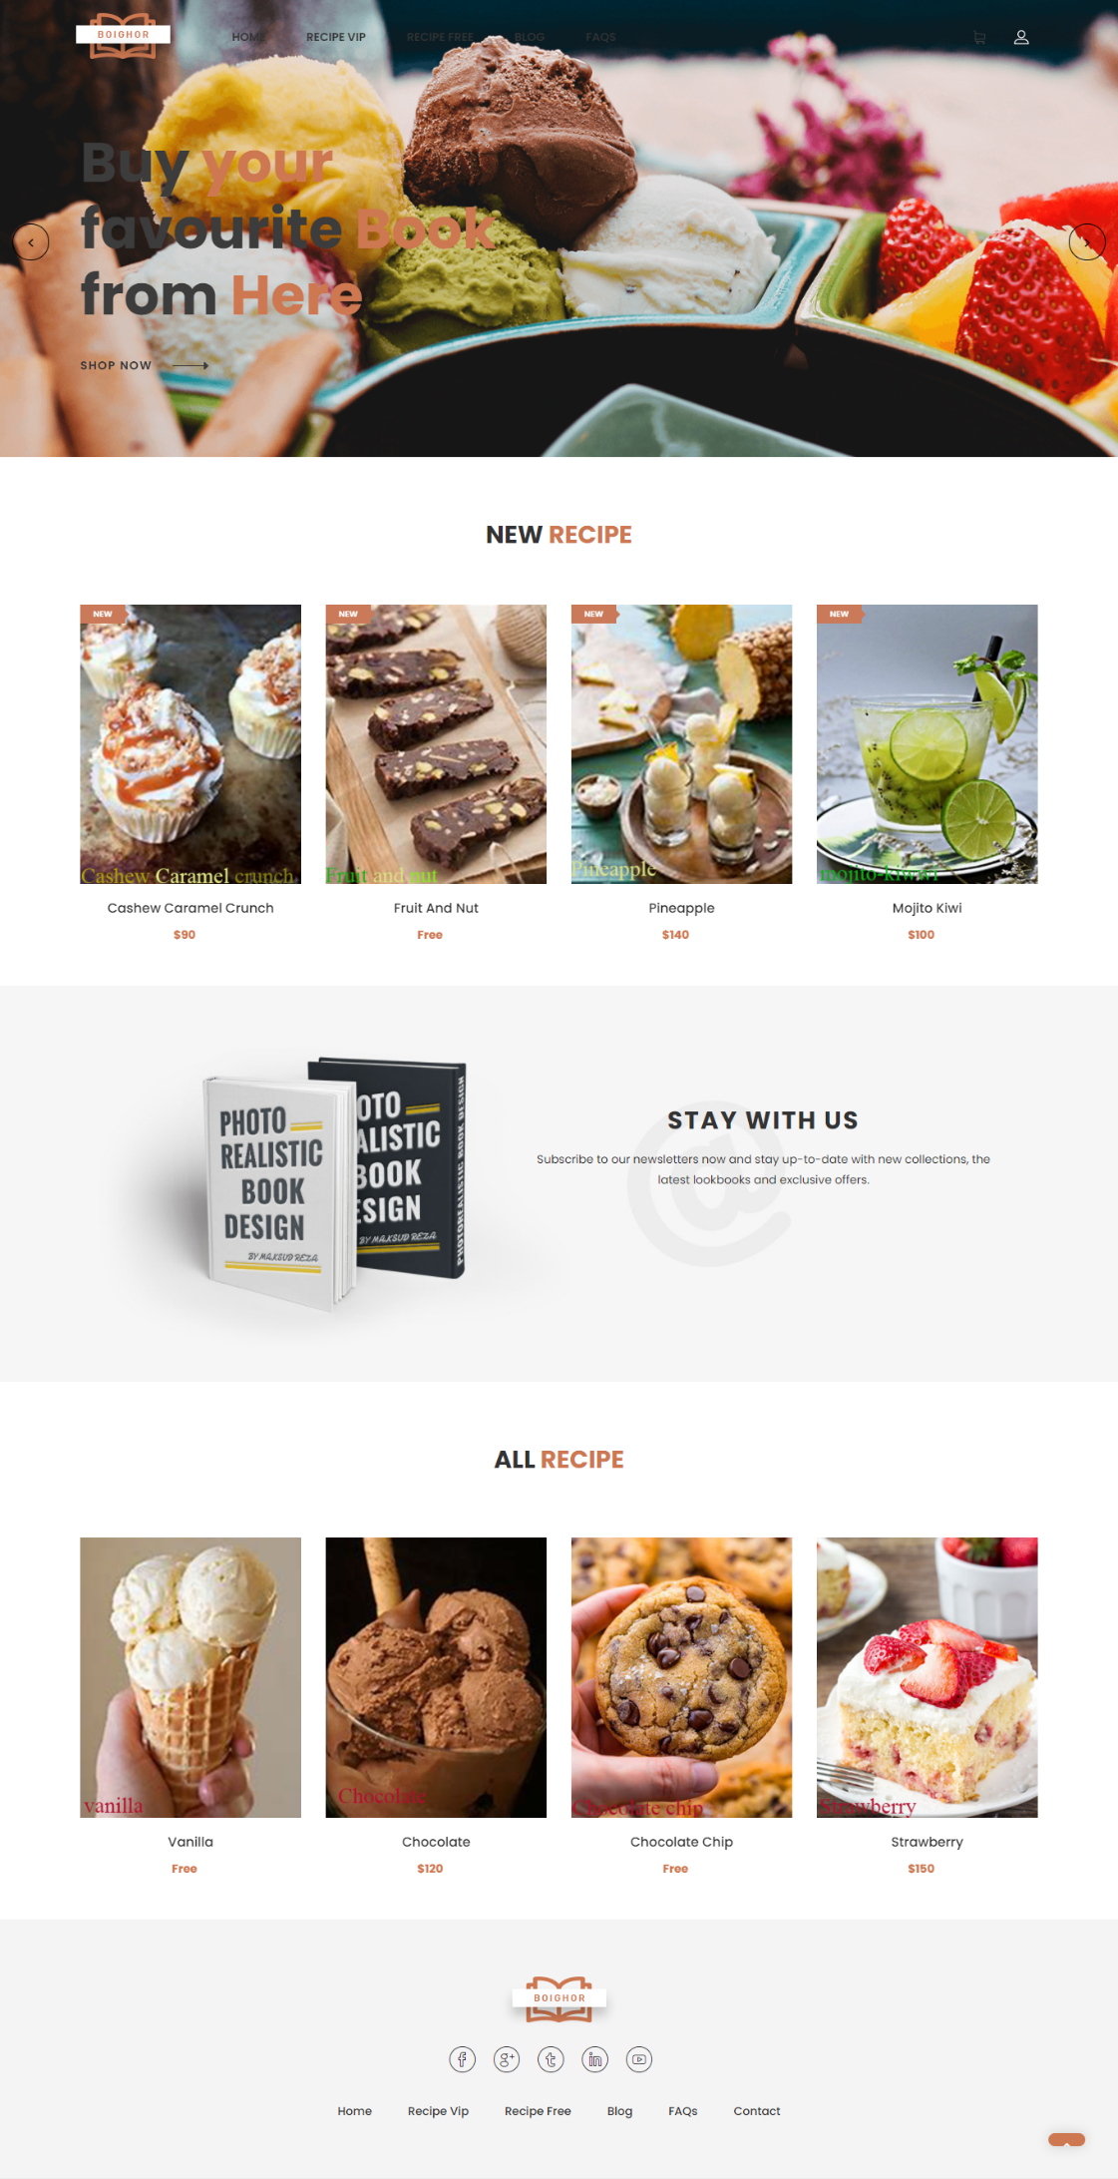

**9.2) Login**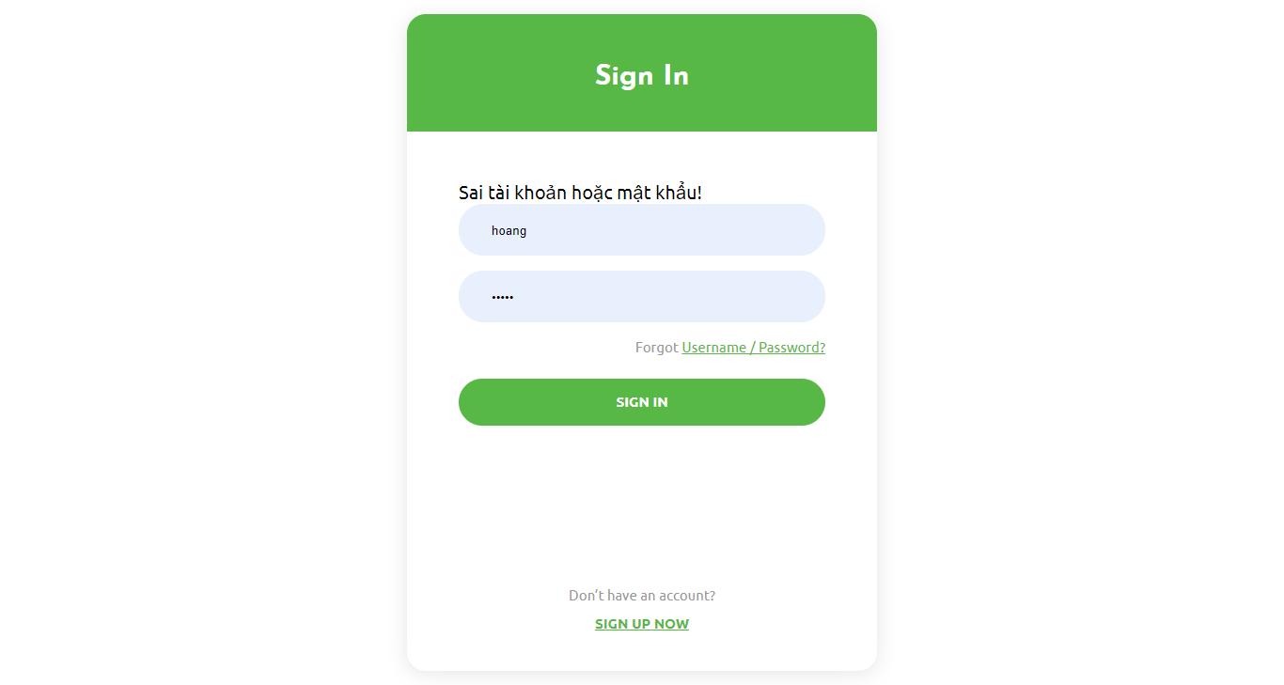

**9.3) Đăng kí**

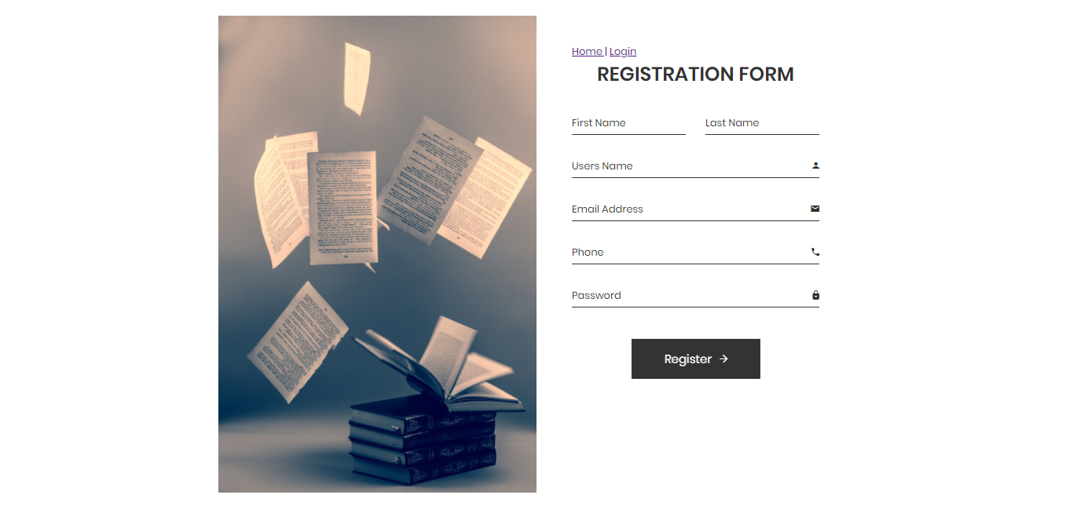

**9.4) Sản phẩm**

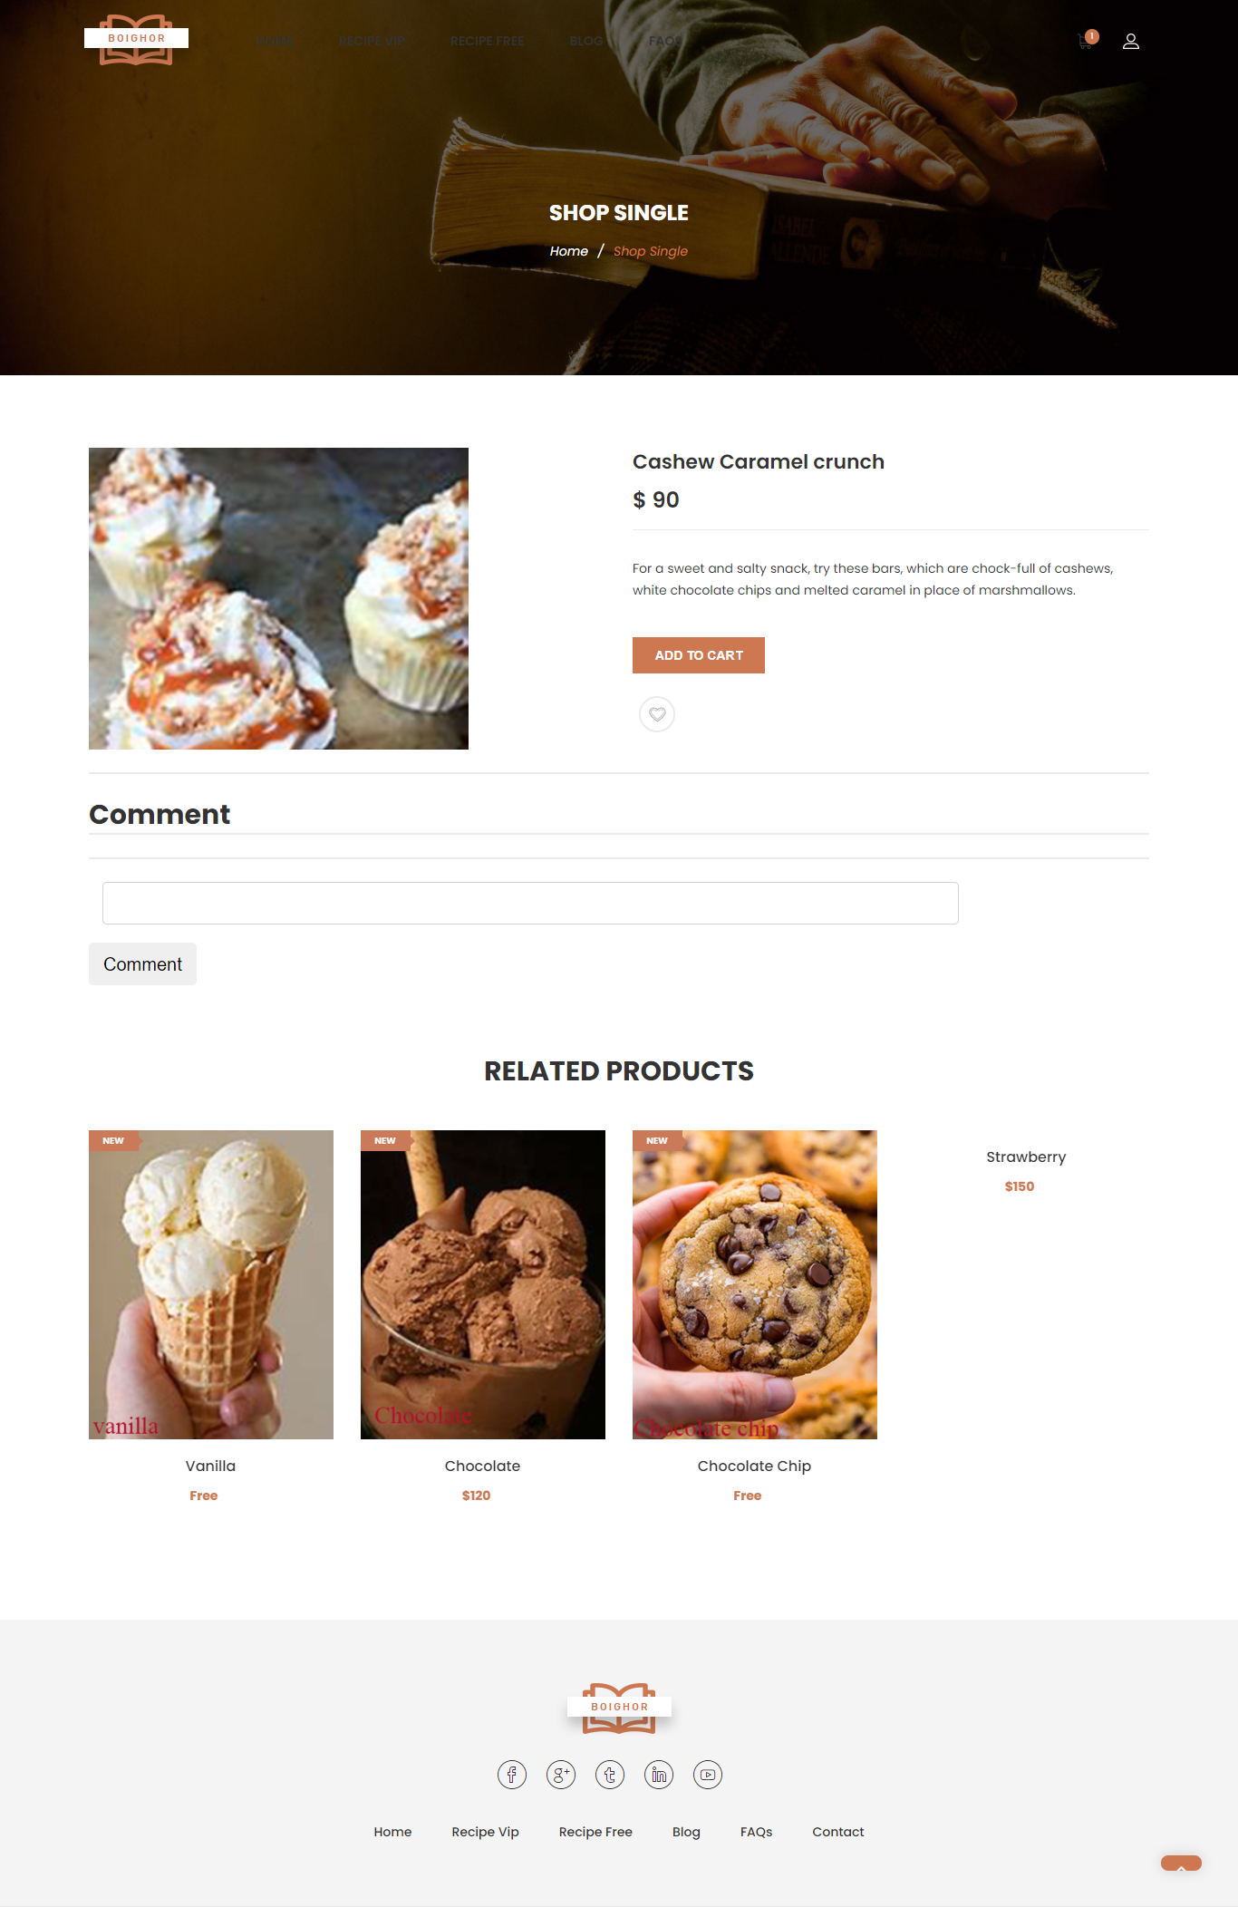





**9.5) Giỏ hang**

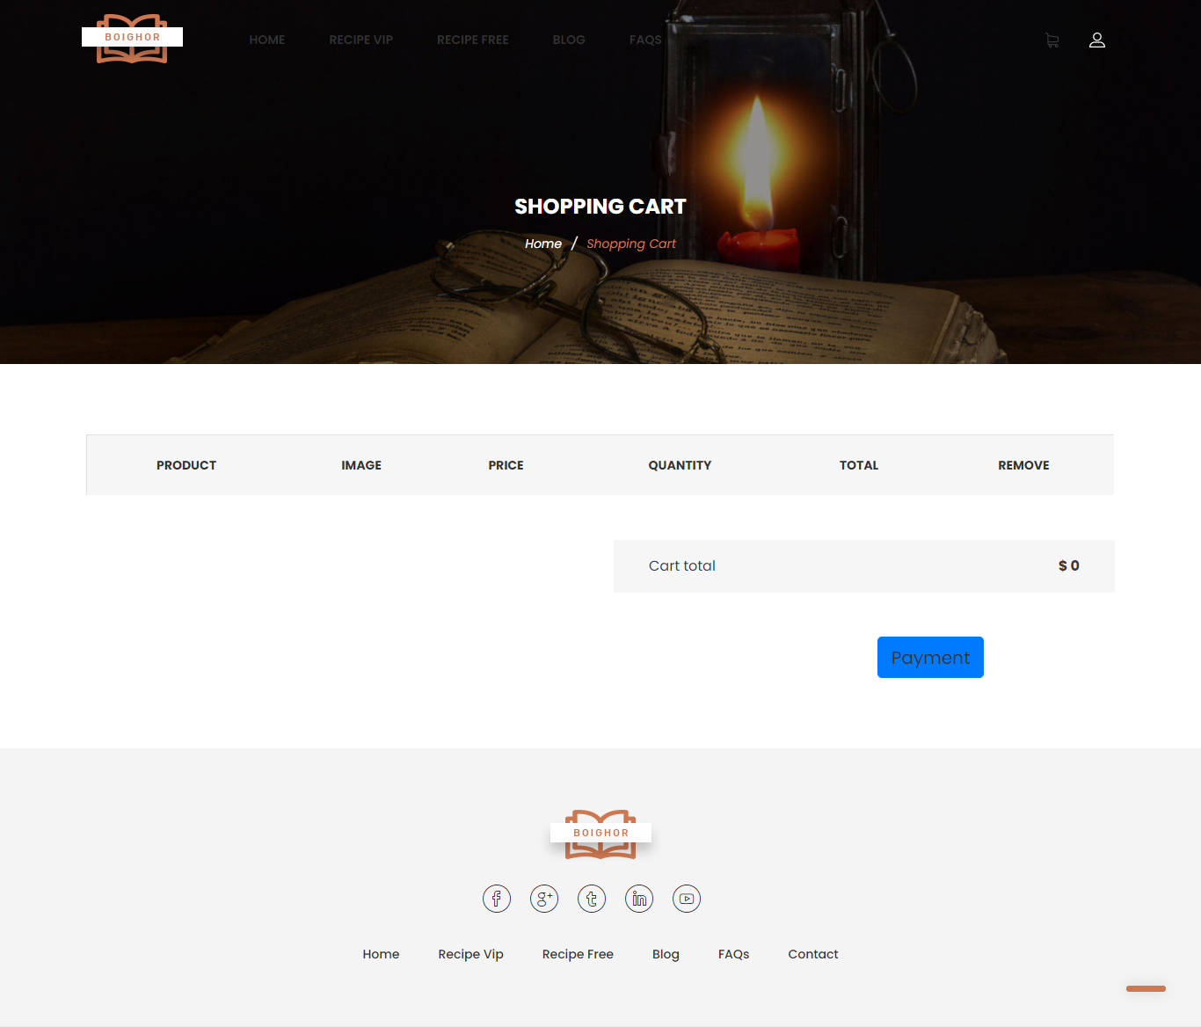

**9.6) Blog**

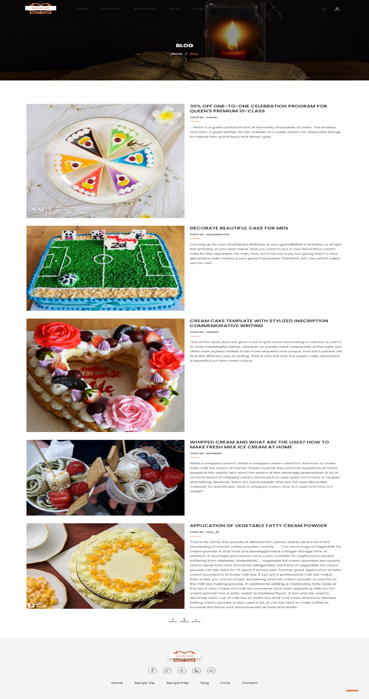

**9.7) FAQs**

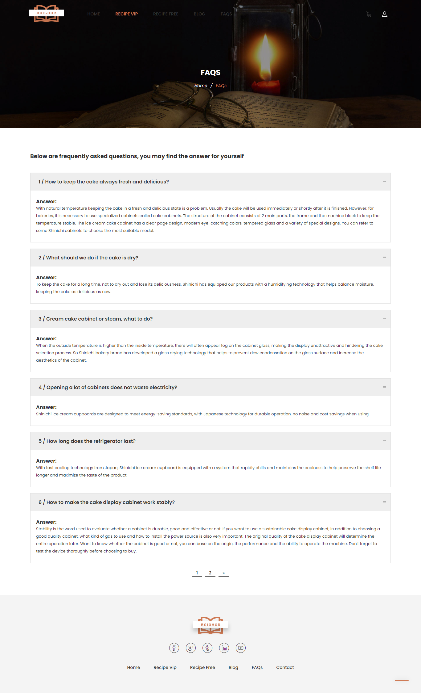

**THE END**